Mikhail Andreev

EC527 Assignment 7

Using bme-compsim-55 (3.6 GHz)

**Part 1: “Hello World!”**

The code that accomplishes this is:



The output given by this code is:



**Part 2: Parallel For**

By examining the output for the 3 code versions, we can graph the output of the serial values versus the parallel versions, which in turn will tell us the overhead and the break-even point. In the following graphs, the blue graph is the serial version, the red graph is the OpenMP version, and the green graph is the time it would take to do computations without thread overhead.

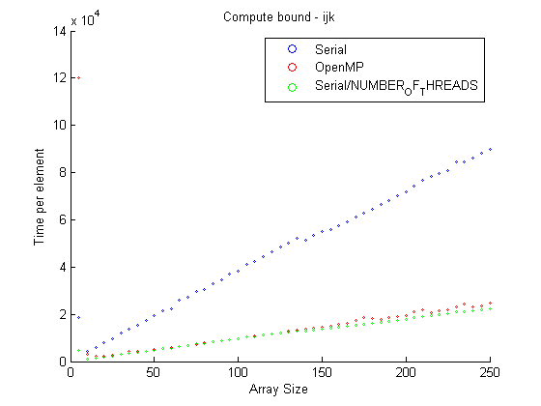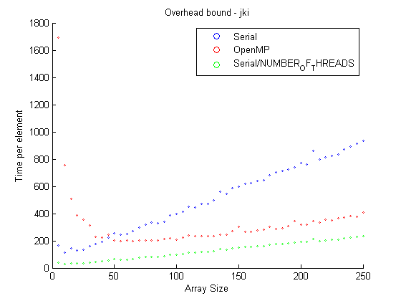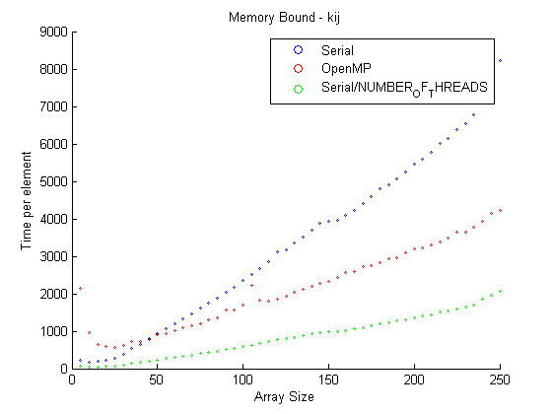

These graphs can tell us the overhead values by averaging the difference between the parallel version and the no-overhead parallel version.



From these graphs we can also see the break-even points. The break-even point for the compute bound is at 10 array elements. The break-even point for memory bound is at 50 array elements. The break-even point is at 45 array elements.

**Part 3: MMM, 3 loop version**

1. Running the code with different array sizes generates the following graph:

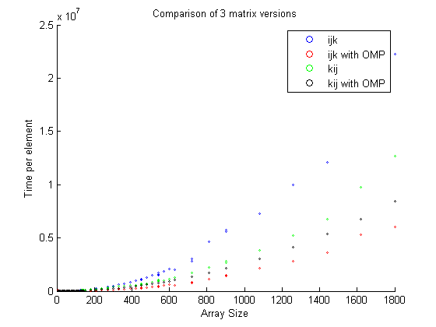

**Part 4: OpenMP on real programs**